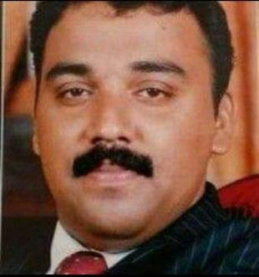

**CURRICULUM VITAE**

**SHERIN KOLAMKOTTU CHERIAN**

**Mobile No-9746257055**

**Email : sherin8500@gmail.com**

**OBJECTIVE**

A suitable placement enabling me to utilize my personal and technical skills and at the same time providing me with experience and challenges allowing for continued professional and personal growth

**Technical Qualification** : Automobile Diploma in motor Vehicle

Mechanism certified by Govt. of India

**Educational Qualification** : Pre Degree Course from Mahatma

Gandhi University Kerala

**Area of Experience/computer skills** : Vast experience as service advisor for

Luxury Vehicles Doing road test and

troubleshooting mechanicaland electrical

with computer DTC. Well versed in

operating karridge program

**Work Experience**

**Aug 2018 - July 2020**

Service supervisor-working as service supervisor and customer care manager as Nawahwsharq company LTD (Premium collection). Mainatance of Bugatti, Maclaran, Pagani and Koenigseeg Premium Cars.

**December 2009 until August 2018.**

**Senior Service Advisor**

Working as senior service advisor for Volvo luxury cars under first Motor Co (AL futtaim Group) Riyadh.Job Includes customer care and troubleshooting the vehicle problems, accessing the cost related to the vehicle repairs and guiding the mechanics to diagnose and do computer testing with DTC, and handling the manufacture warranty procedures.

**July 2008-Nov 2009**

**Service advisor at Wallan automobiles, Riyadh**

(Authorized Hyundai Dealer)

Responsible for the maintenance of all Hyundai vehicles related to the services and maintenance

**April 2003 – June 2008**

Workshop in charge at Rohn products Int’ Arabia Ltd.

Responsible for the maintenance of cars and SUV’s Including various equipment and machineries

**September 2002-March 2003**

Mechanic-Vinnell Arabia (Saudi Arabian National Guard Modernization program)

Worked as automotive mechanic in motor vehicle Maintenance department in vinnell Arabia, which includes European, American and Japanese cars. Job includes diagnose, road test and troubleshooting with computer checkup

**December 2002-august 2002**

Worked as mechanic in Hero motors ,Kerala, India

**November 1999-November 2000**

Woked as mechanic apprentice in maintenance department under Kerala State Road Transport Corporation, Govt of kerala, India.

**June 1999 – December 1999**

Worked as mechanic Trainee in AVG Motors Limited, Authorized dealer of Suzuki Maruti Motors in Kerala.

**September 1998 – June 1999**

Worked as mechanic in aiswarya motors Limited ,Authorized dealers of piaggio Vehicles.

**Personal Details :**

Date of Birth : 30th may 1979

Nationality : Indian

Religion : Christian

Marital status : Married

**Declaration**

I here by declare that all the statements mentione above are true and correct to the best of my knowledge and belief.

**SHERIN. K. CHERIAN**